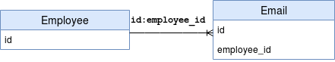

* Owning side & referencing side
* **@JoinColumn** 
  + Giúp xác định column dùng để Join 1 entity hoặc 1 list entity
  + Định nghĩa ở referencing side để tạo 1 mapping vật lý tới owning side

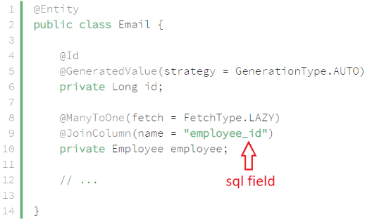

* **mappedBy attribute**

Sử dụng để định nghĩa referencing side (non-owning side)

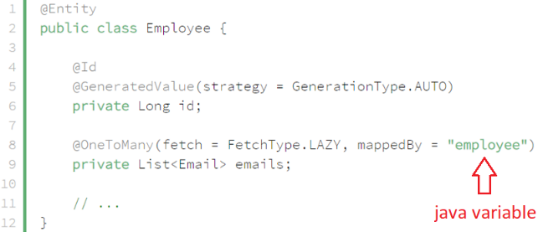

* **Reference**

<https://www.baeldung.com/jpa-joincolumn-vs-mappedby>